**Build Instructions**

**Parts Crib Database**

**By: Mohand Ferawana**

**Introduction**

The Parts Crib Database Project is a project trying to achieve a quick and efficient way of renting items from the parts crib. The goal is to keep track of tools and equipment as well as students holding them back after rental.

**System Diagram**

The Parts Crib Database Project functionality is to be able to read student number from the student id cards and the associated part items from the parts crib and then be placed in a database. Now understanding what the concept of the Humber Parts Crib Database Project is, the system diagram can be easily interpreted.

**Input** **Process** **Output**

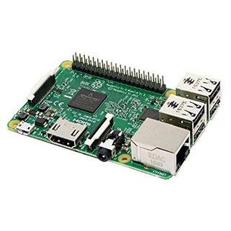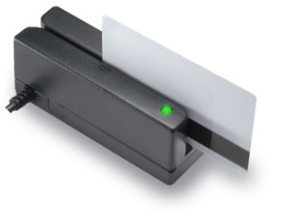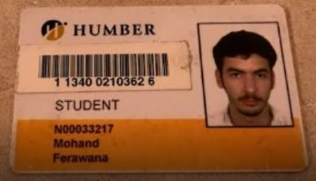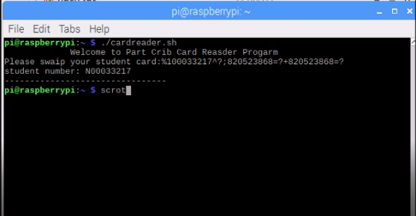



**Bill of Materials**

The main materials/components required for my project are a raspberry pi, magnetic card reader. In addition, the raspberry pi requires a monitor, keyboard and mouse to be setup. My budget was simple and not expensive except for the raspberry Pi3 kit for $79.99 and Magnetic Stripe Card Swipe Reader for $23.89. My full excel version of my budget is provided in my GitHub blog page.

**Time Commitment**

The time commitment for my project took about 15 weeks to complete in its entirety. Firstly, the project began with ordering parts through websites like amazon, eBay and all sorts of technology base websites. Once ordered, the delivery took about week and a half (week 2 & 3) to come in. As everything arrived, I then began to setup my raspberry pi and all its components which took my about 1 hour to setup. As week 5 approached I printed out my PCB and started soldering everything. The soldering approximately took me about 2 hours to complete at school. Afterward, at week 6 and week 7 I started to test my raspberry pi and its components which took me about 3 hours in its entirety. Firstly, I tested if the PCB by implementing the code given by the teacher that can test if the lights work and the sensors. Then I started implementing the code in which will read the student number from student ID card by magnetic strip card reader which then again took me about 3 hours to complete.

**Mechanical Assembly**

The assembly of my project is very simple first connect the magnetic strip card reader to the USB port on the raspberry pi and then connect the raspberry pi to a power outlet. And that’s how-to Assembly all the parts of my project.

**PCB / Soldering**

We were also given a detailed step by step procedure as well as some materials for soldering project. Upon completion, we tested for shorts and open circuits in our finished product before mounting the board on the Pi.

**Power Up**

The power begins with the setup of the raspberry pi. First connect the raspberry pi to an external monitor, keyboard and mouse and then to a power outlet. Once powered on the setup of the OS will commence which will take a few minutes.

**Unit Testing**

The unit testing begins the PCB as mentioned in the power up. It is recommended to use the code that is given by Humber College to test if the light indicator works. The light indictor can work with the command “sudo./traffic2B”. The next step is to check if the magnetic strip card reader work. This can be done by open a text file and swap student card. Once the card swapped, should appear data on the text file. if it gives back data that mean a its working. After this, the code created for this project can be used which is in my GitHub page. The program can run by typing “./cardreader.sh” in the command line.

**Production Testing**

The production testing is simple. Run the barcode program cardreader.sh and swap the student card. Once swapped the student number will appear in the terminal.